
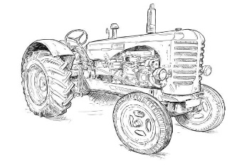
LAKE COUNTRY ANTIQUE TRACTOR ASSOCIATION
BRANCH 145
JUNE 2, 2025 MINUTES

President, Don Hatton, called the meeting to order at 7:10 with twenty in attendance. Our special guests were students who were awarded our scholarships for the year. Ava Nivison from Alba-Golden, Micayla Burnett from Brownsboro, and Elizabeth Bruwer from Lindale were present. Elizabeth was presented her scholarship at the beginning of the meeting. Each student had a parent in attendance. Doyle Gandy read a letter of thanks from his grandson, Tucker Abernathy from Chapel Hill. Tucker had to work and was unable to attend the meeting. Ava presented a note of appreciation to the group for her scholarship. Bradie Cooper from Brownsboro and Ava Perkins from Malakoff were unable to attend also. We think we have a great group of young people to receive our scholarships this year.

Health concerns mentioned were: Gordon McCosh’s wife is doing better after her stroke, Bobby Steel from the Lone Star Club is still have problems but is hang in there, and Patsy Hatton will have knee replacement surgery on June 24.

Minutes from the April meeting were accepted as written.
The financial report was approved as presented.

Past Events
The Canton Swap Meet was held on April 16 and 17. There were thirteen clubs in attendance. The evening meal was delicious! April 10 and 11 are the dates scheduled for next year.
The Henderson Show and Pull on April 25 and 26 was a good one but the turnout was low.
The Noonday Baptist Church Tractor Show on May 3 was a success.
The LFTB Tractor Pull and Show in Athens was a very good one. The lawnmower turnout was light but around fifty four tractors were registered. Next year this pull will be held on March 28.

Upcoming Events
June 6-7 -----------Golden Harvest Days
June 14 ------------Show and Pull in Terrell
July 4 ---------------Maybank Tractor Display
August 4 -----------next club meeting in Mineola

We need our members to show up and help us out at the Terrell pull. Our sled will be used.

Scott Young is working on a Trail Ride out of Hainsville, near Mineola. November 15 is the date that is planned. We will get a printout of the trail at a later date. Don will be the contact person for this event.

Everyone was reminded that new officers will need to be elected in December.

The meeting was adjourned at 7:50.

Respectfully submitted,
Sally Smith

