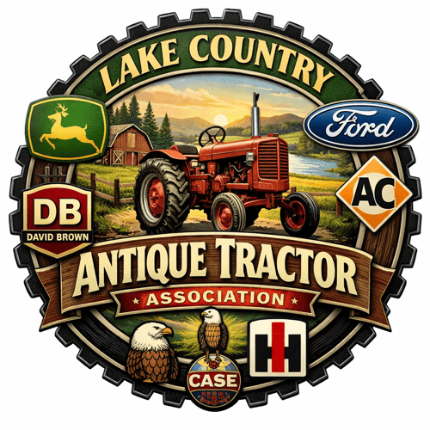

LAKE COUNTRY ANTIQUE TRACTOR ASSOCIATION
EDGETA BRANCH 145
JULY 7, 2026

Club president, Mike Banks, called the meeting to order at 7 PM with twenty in attendance. Don Hatton gave the opening invocation. Sally Smith introduced Luke Rogers, one of our scholarship recipients from Winnsboro, to the group. Luke told the group that he will be attending Texas A & M University and plans to major in mechanical engineering. He hopes to work at John Deere, Kubota or Cummins one day. Minutes from the June meeting were adopted with one correction. The parade in Emory will be to honor veterans, not Help a Child. The financial report was distributed to everyone and approved.

No old business was discussed.

NEW BUSINESS
1. A committee consisting of Sean Matlock, Don Hatton and Mike Banks was appointed for the purpose of updating the Club By-Laws. Alicia Moore made the motion to form this committee and the second was made by Steve Williams. All approved.

2. Apparently, the pull at Pale Horse in Big Sandy is not going to take place. There seems to be an issue with insurance for the event. Scott Young made the motion to cancel the event from our calendar. Joe Bob Busby made the second and the motion carried.

3. Dawn Matlock is proposing that we get club shirts for our members. Members were asked to let her know if we were interested and to make any suggestions to her about the design of the shirt.

4. We were asked if we wanted to continue meeting at the Jalapeno Tree. Bret Myers made the motion to try it one more time. A second was made and all agreed.

5. Scott Young mentioned that he had the registration form for a parade during the Oil Festival in Hawkins on September 26. He also told us that the Canton Swap Meet was in the planning stages and would take place in April.

The meeting was adjourned at 7:20.

Respectfully submitted,

Sally Smith

UPCOMING EVENTS

August 3 Next meeting of the LCATA at the Jalapeno Tree in Mineola. 6 PM to eat and 7 PM to meet
September 19 North Texas Tractor Show and Pull in Royce City. LCATA Sled
October 3 Autumn Trails Show and Pull in Winnsboro. LCATA Sled
October 3 State Show and Swap Meet in Temple.
October 10 Fanin County Fair and Tractor Pull in Bonham. LCATA Sled
October 24 Golden Sweet Potato Fest and Tractor Pull. LCATA Sled

