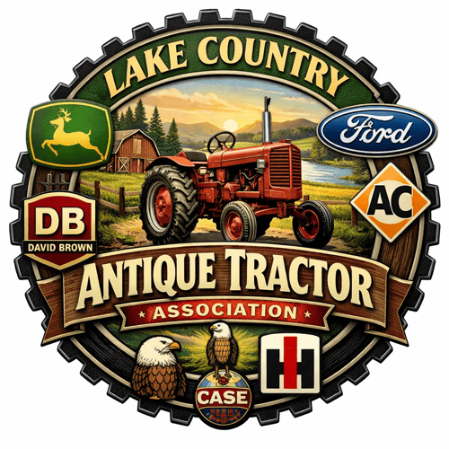

LAKE COUNTRY ANTIQUE TRACTOR ASSOCIATION
EDGETA BRANCH 145
JUNE 1, 2026 MINUTES

The meeting was called to order by Mike Banks, president of the club, at 6PM with approximately twenty six in attendance. Palmer Johnson gave the opening prayer. It was announced that the following seniors had received scholarships from our club: Kenzie Hartsell from Alba Golden, Adlee Frazier and Luke Rogers from Winnsboro, Emerson Fite from Sulphur Bluff, and Keslee Gandy from Chapel Hill. We were very pleased to have Keslee, Adlee, and Kenzie with us tonight. They were introduced to the group and their pictures were made for our website. The minutes from the April meeting were approved. Brenda Wisdom, club treasurer, gave the financial report. It was approved as presented.
OLD BUSINESS
1. Don Hatton reported on the Canton Swap Meet. The organizers of the event went in the hole around $26 mainly because they were light on vendors. At any rate, the event is in the planning stages for next year and people are looking forward to it.
2. Joe Bob Busby reported that there were around ten tractors which made the entire trail ride which he organized. Everyone had a good time.

New Business
1. Raymond Shelton from Pale Horse Ranch in Big Sandy, made a presentation to the group. They have a 765 acre ranch which sponsors a Family Fun Day every Saturday. He would like for LCATA to present a tractor show and pull. They have a covered arena in which the event would take place. Sean Matlock made the motion that we put on the show and pull. Scott Young made the second. The motion was approved. The site is located off of State Highway 2911. The start time will be around 10 AM.
2. Don Hatton reported that he had been contacted by some people in Emory and they are trying to organize a parade for Help a Child. We will learn more about this later.
3. LFTB Cowboy Church is planning next year’s pull for March 3 or April 13.
4. We need a new meeting place. The Red Dome closes at 7 PM and that does not give us time for our meetings. It was decided that the Jalapeno Tree in Mineola might be a good place to try. Sally Smith made the motion to try out this place and see how things work out. Scott Young made the second and the motion carried.
5. Don told the group that the V-8 tractor drivers are wanting to know if they can pull in Bonham. As far as we know, they can pull in Bonham but not in Terrell, Golden, and Winnsboro.
6. Sean Matlock made the motion to begin having monthly meetings. The second was made by Don Hatton and it passed. We will meet next month at the Jalapeno Tree in Mineola.
7. Scott Young mentioned that a Plow Day was being discussed for November. He will have more information at the July meeting.

The meeting was adjourned at 6:55.

Respectfully submitted,
Sally Smith

UPCOMING EVENTS FOR LCATA
July 25 | Show and pull at Pale Horse Ranch in Big Sandy
Sept. 19 | Royce City (North TX Tractor Club) Pull
Oct. 3 | Autumn Trails Tractor Pull in Winnsboro
Oct. 10 | Fanin Co. Fair and Pull in Bonham
Oct. 24 | Golden Sweet Potato Fest and Pull

